**GIT GROUP ASSIGNMENT**

**GROUP – 4**

**TOPIC – CHECKOUT**



**Submitted to :- Submitted by :-**

**Mr. Sonu Mehrotra Prince Agrahari**

**Soumya Bhushan**

**Riya Kumari**

**Aditya Sahu**

**Gaurav Gupta**

**Checkout Command Options :-**

1) By using the "--track" parameter, you can use a remote branch as the basis for a new local branch; this will also set up a "tracking relationship" between the two:

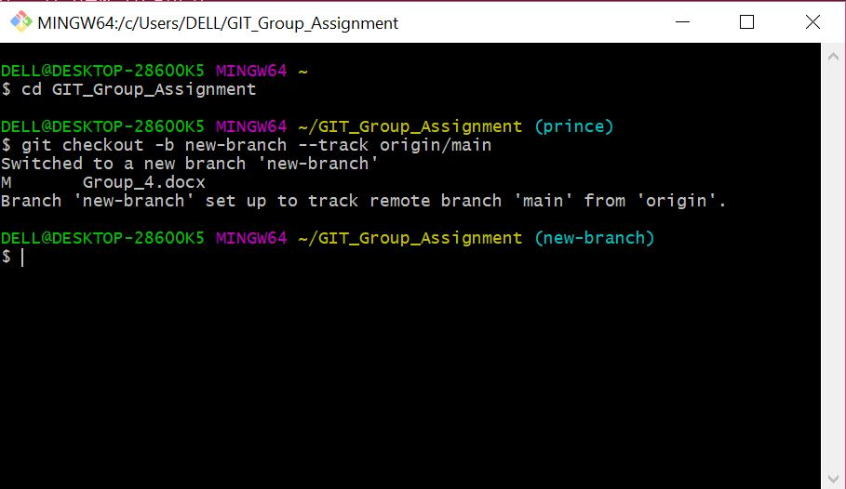

2) The below command you can used for fetching all the branches from the remote repository.

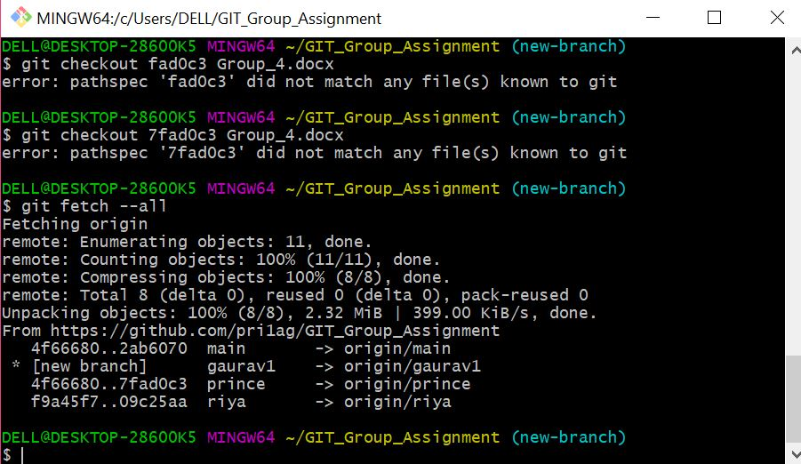

3) The following command used for the name of a commit at which to start the new branch.

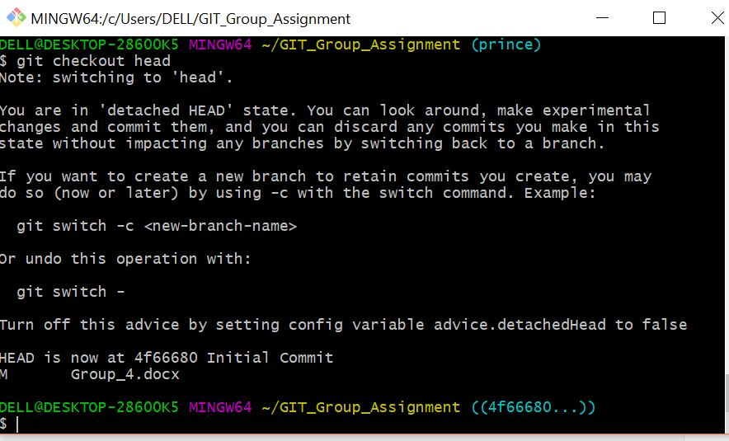

4) git checkout -q command is used to quiet, suppress feedback messages.

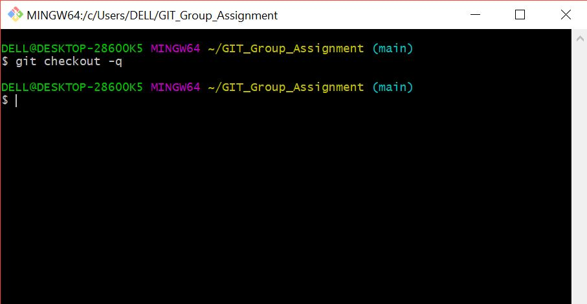







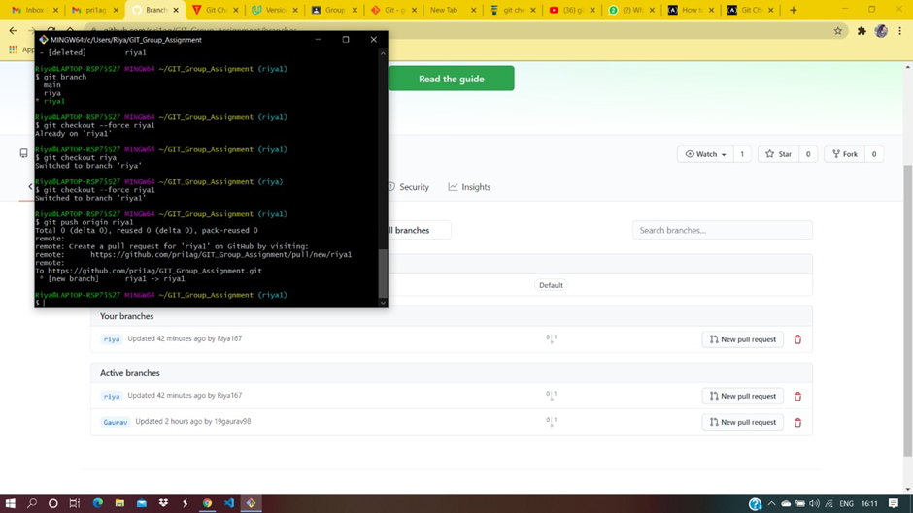



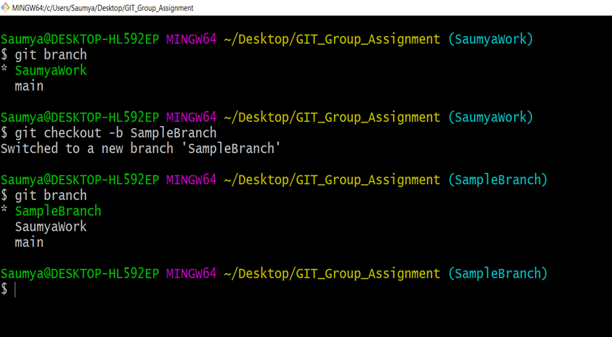

* Checkout to remote Branch

First you need to fetch all the changes from remote branch

**git fetch –all**

then you can checkout to the remote branch to see the changes of your collegues

git checkout <remoteBranch>

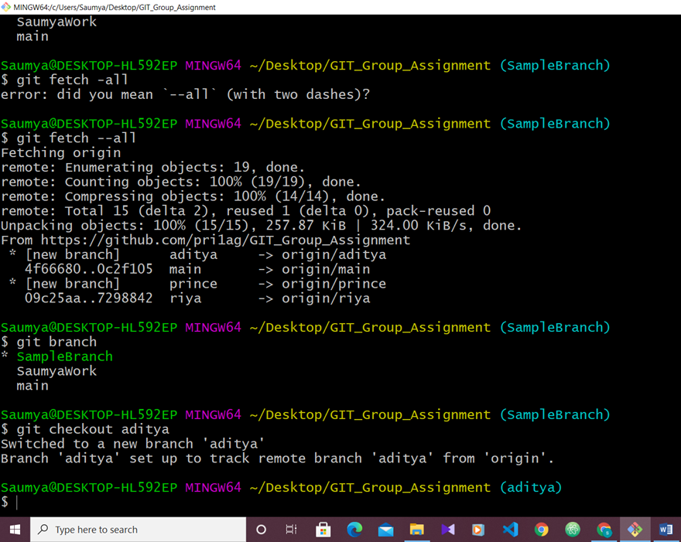

This pic shows that I have first fetched the data from remote repo and then moved to the branch of remote repo (aditya).

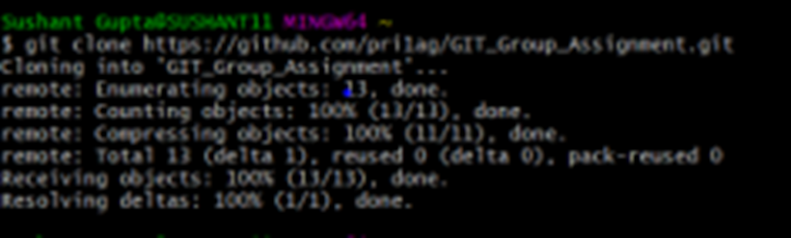

* First Cloning the remote repository into our local directory using $ git clone “repo http”

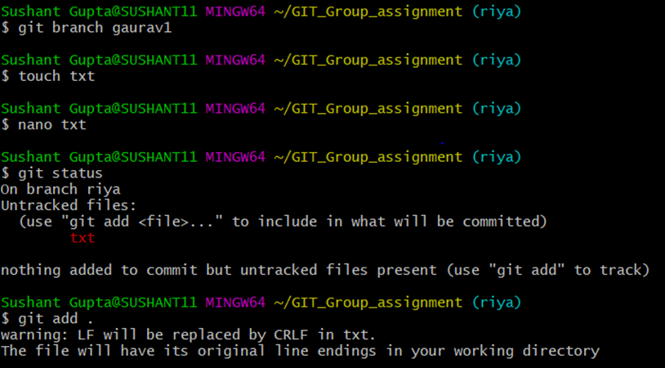

* Then making a new branch under repository using
* $ git branch “branch-name”
* Then making txt file using $ touch command and adding text to it .
* Then using git add command to add the file in the working directory

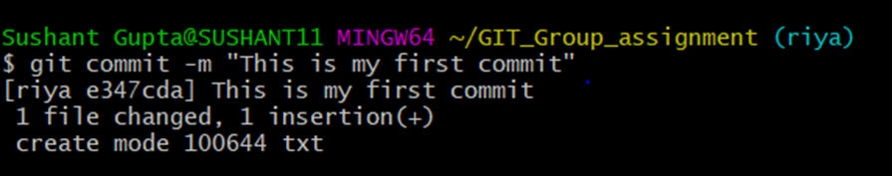

* Using git commit command I am committing that file and I have given a message for that commit to.

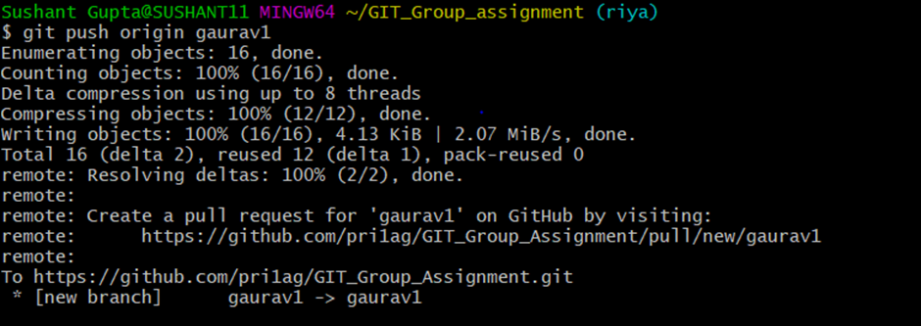

* Now I am pushing my local repo into the remote repo using command

$ git push origin “branch-name”

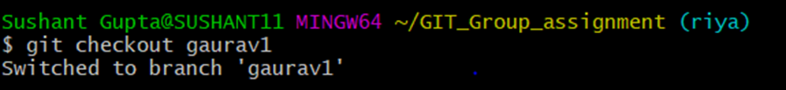

* I was working on riya branch but if I want to swtich my branch to gaurav1 then I use the command

$ git checkout gaurav1



* It undo changes you’ve made to a file in your working directory. This will revert the file back

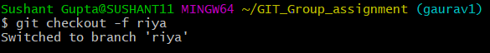

* Git -force/-f option with checkout command to force git to switch branches , even if you have un-staged changes.



* First Cloning the remote repository into our local directory using $ git clone “repo http”

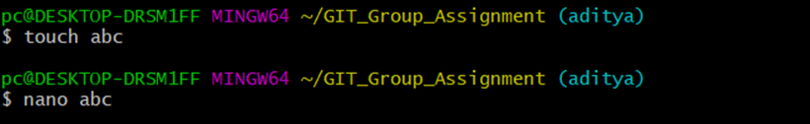

* Then making a new branch under repository using
* $ git branch “branch-name”
* Then making txt file using $ touch command and adding text to it .
* Then using git add command to add the file in the working directory

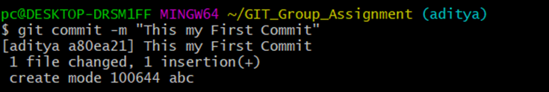

* Using git commit command I am committing that file and I have given a message for that commit to.



* Now I am pushing my local repo into the remote repo using command

$ git push origin “branch-name”

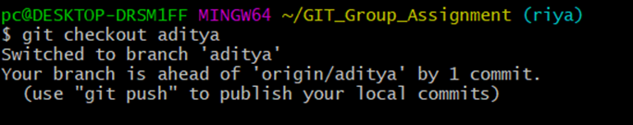

* I was working on riya branch but if I want to swtich my branch to gaurav1 then I use the command

$ git checkout gaurav1



* It undo changes you’ve made to a file in your working directory. This will revert the file back

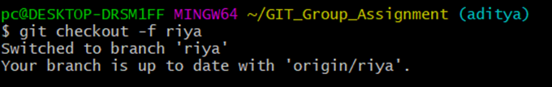

* Git -force/-f option with checkout command to force git to switch branches , even if you have un-staged changes.

**GitHub Repository Link :-** https://github.com/pri1ag/GIT_Group_Assignment